|  |  |
| --- | --- |
|  | **AMERICAN INTERNATIONAL UNIVERSITY – BANGLADESH (AIUB)**  **Faculty of Engineering** |
| **Semester**: Summer 2018-19 **Course Name**: DIGITAL ELECTRONICS LAB **Project Proposal** | |
|  | |

**Project Title:** Water Level Alarm Using 555 Timer

**Project Objective:**

* To gauge and manage water levels in a water tank
* Automatic water level indicators ensure no overflows or running of dry pumps
* Saves money by using less water and electricity
* Can help avoid seepage of walls and roofs due to tanks overflowing
* Automatic save you can save manual labor time
* Consumes very little energy, perfect for continuous operation
* Shows incitation of water levels in any type of tank

#### ****Circuit Diagram:****

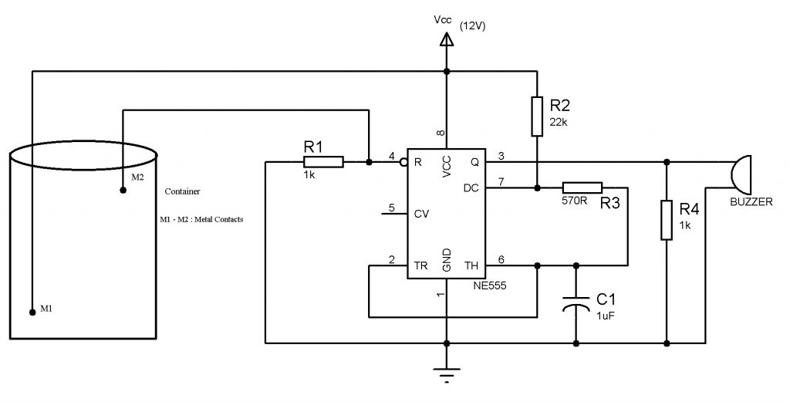

#### Components Required:

* NE555 Timer
* Resistors
  + R1,R4-1K
  + R2-22k
  + R3-570 Ohm
* Capacitor- 1UF
* Buzzer
* Connecting wires

**Methodology:**

The circuit uses a 555 timer in a stable mode with R1=22k ohms, R2= 570 ohms and C1=1 uF. The frequency of the given a stable circuit is around 62 Hz.

The two probes which are shown in the circuit should be kept at the high level for the water. The distance between the probes should be less than a few centimeters to ensure that the conduction between the probes will take place when water is touched to these probes.

When the water level rises to the height of the probes, then the 555 circuit will get enabled and the output of the 555 timer produces a square wave output with a frequency of about 62 Hz. This output is given to the buzzer.

The logic Implemented in this circuit is, 555 timer is enabled when its reset pin is connected to logic high. But initially it is connected to ground. When the water level is maximum this pin is enabled and this drives the 555 timer into a stable mode.

**Group member:**

|  |  |
| --- | --- |
| **Name** | **ID** |
| Tareq Md Rabiul Hossain Chy | 17-34649-2 |
| Md Khairul Alam Mazumder | 17-35185-2 |
| Sudipto Saha | 17-34582-2 |
| Shanto Kumar Saha | 17-34699-2 |
| Asward Muntasir | 17-34695-2 |